**Activity 8 - Advanced Keyboard Tricks**

**clear** – Clear the screen

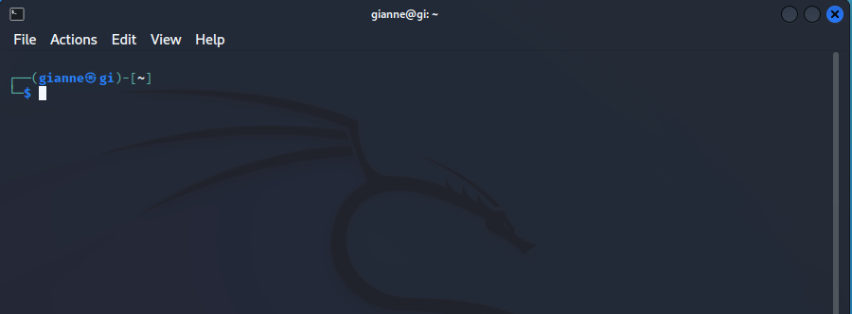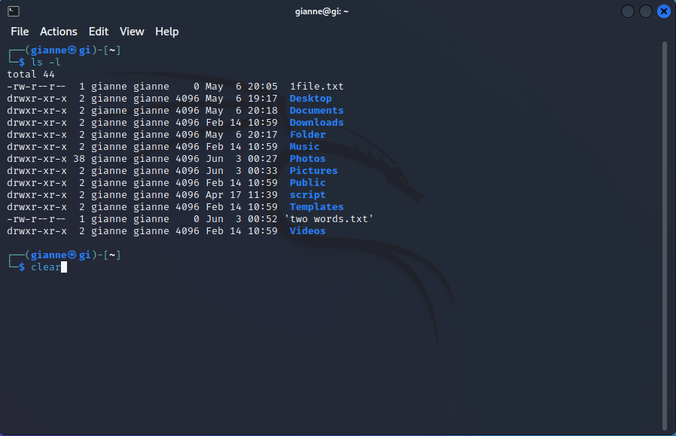

**history** – Display the contents of the history list

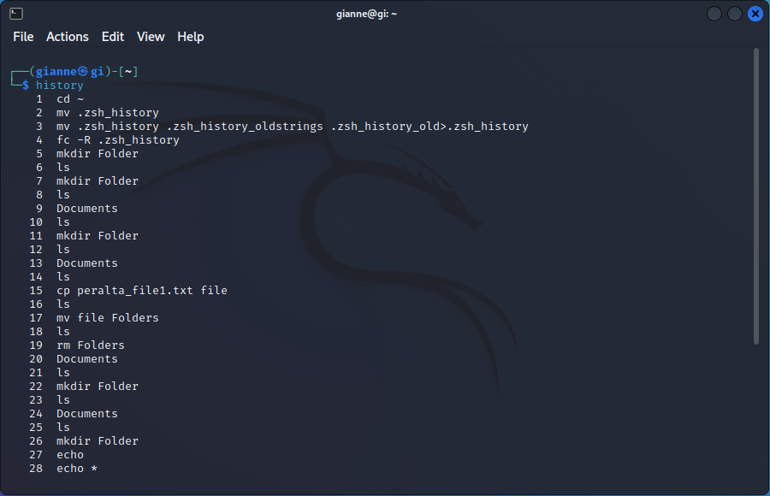

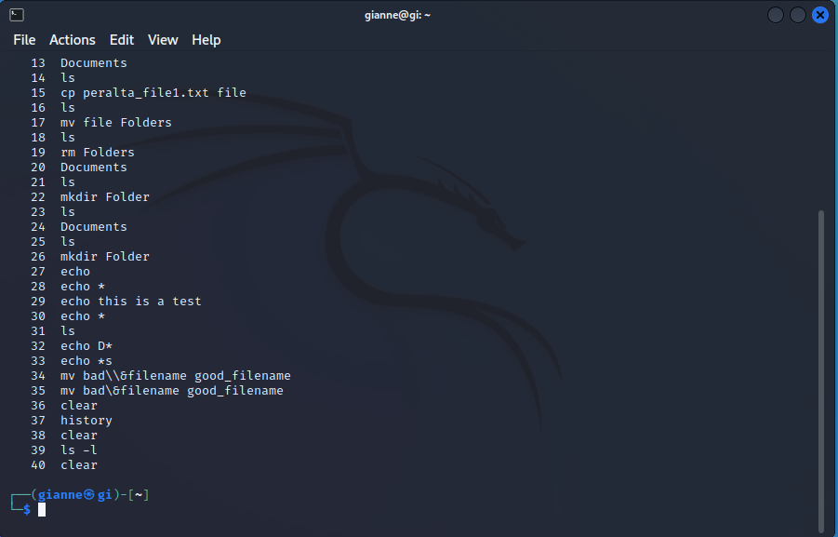

**Command Line Editing -** We know, for example, that the arrow keys move the cursor but there are many more fea - tures. Think of these as additional tools that we can employ in our work. It’s not impor- tant to learn all of them, but many of them are very useful. Pick and choose as desired.

**Cursor Movement-** The following table lists the keys used to move the cursor:

**Table 8-1: Cursor Movement Commands**

**Ctrl-a** - Move cursor to the beginning of the line.



**Ctrl-e** - Move cursor to the end of the line.



**Ctrl-f -** Move cursor forward one character; same as the right arrow key.



**Ctrl-b** - Move cursor backward one character; same as the left arrow key.



**Alt-f** - Move cursor forward one word.

**Alt-b -** Move cursor backward one word.



**Ctrl-l -** Clear the screen and move the cursor to the top left corner. The

clear command does the same thing.

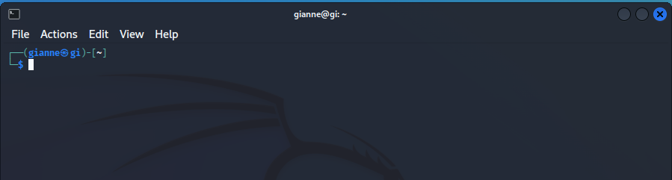

**Modifying Text-** lists keyboard commands that are used to edit characters on the command line.

**Table 8-2: Text Editing Commands**

**Ctrl-d -** Delete the character at the cursor location

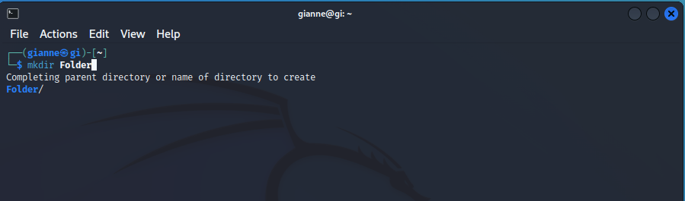

**Ctrl-t -** Transpose (exchange) the character at the cursor location with the one preceding it.

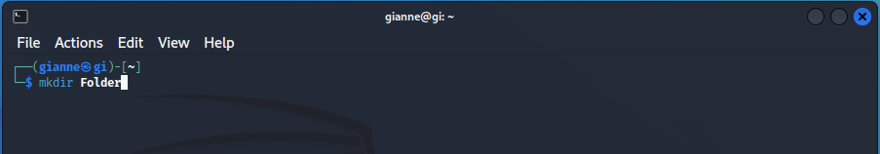

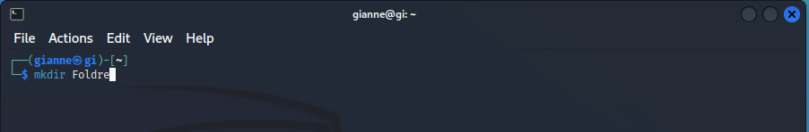

**Alt-t -** Transpose the word at the cursor location with the one preceding it.



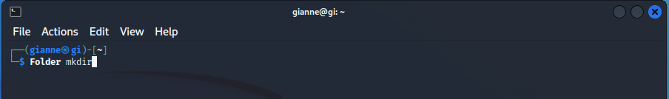

**Alt-l -** Convert the characters from the cursor location to the end of the word to lowercase.



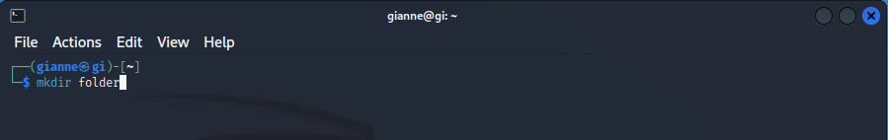

**Alt-u -** Convert the characters from the cursor location to the end of the word to uppercase.



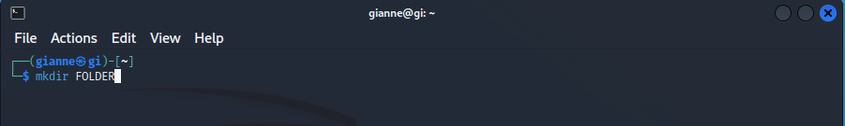

**Cutting And Pasting (Killing And Yanking) Text -** The Readline documentation uses the terms killing and yanking to refer to what we would commonly call cutting and pasting. Items that are cut are stored in a buffer called the kill- ring.

**Table 8-3: Cut And Paste Commands**

**Ctrl-k** - Kill text from the cursor location to the end of line.

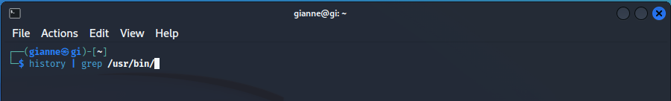

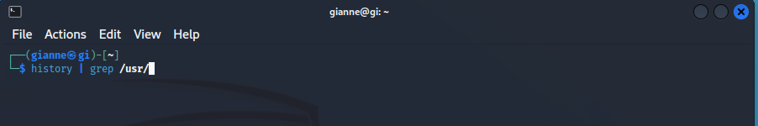

**Ctrl-u -** Kill text from the cursor location to the beginning of the line.



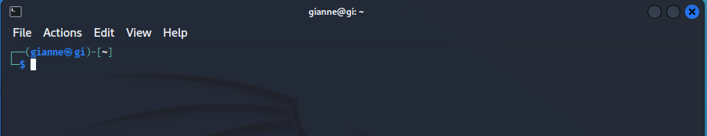

**Alt-d** - Kill text from the cursor location to the end of the current word.



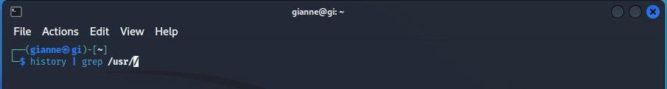

**Alt- Backspace -** Kill text from the cursor location to the beginning of the current word. If the cursor is at the beginning of a word, kill the previous word.



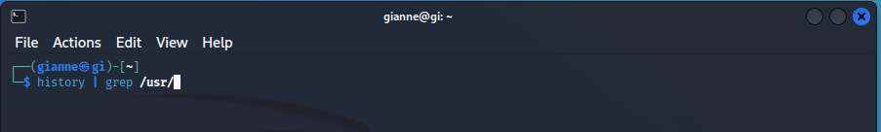

**Ctrl-y -** Yank text from the kill-ring and insert it at the cursor location.



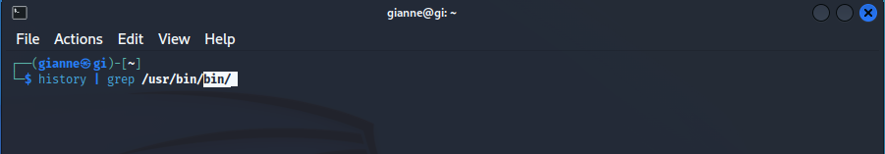

**Completion** - Another way that the shell can help you is through a mechanism called completion. Com- pletion occurs when you press the tab key while typing a command. Let's see how this works. Given a home directory that looks like this:

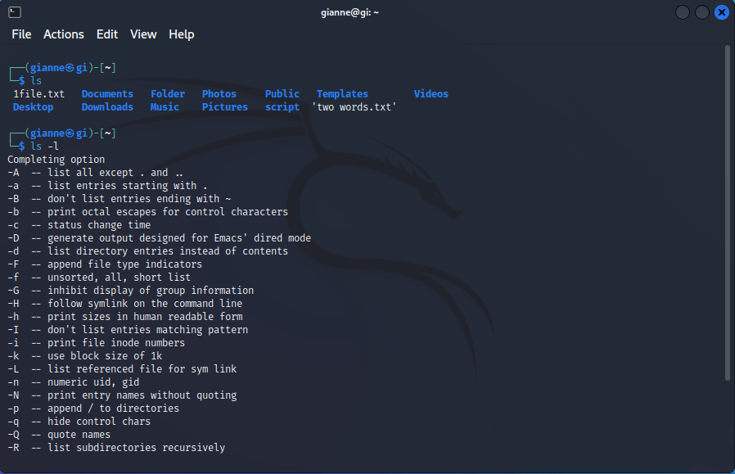

^

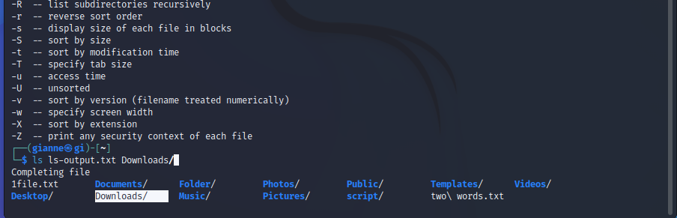

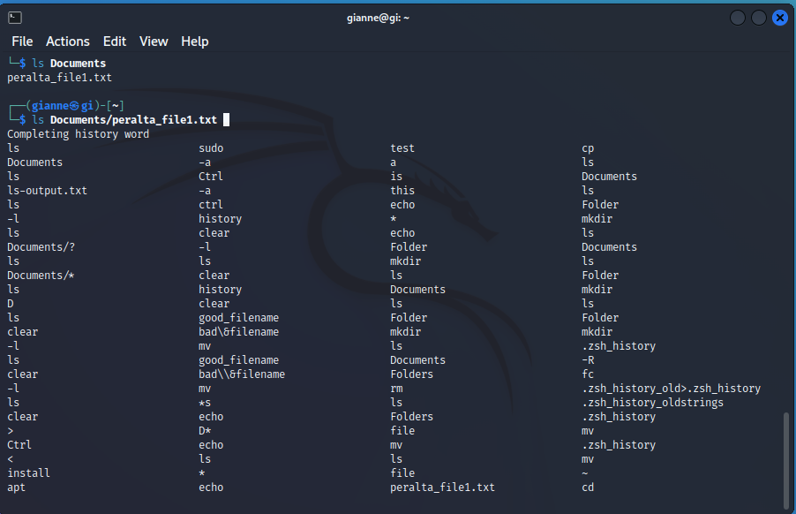

**Using History -** The history facility is a useful resource for reducing the amount of typing you have to do, especially when combined with command line editing.

**Searcing History -** At any time, we can view the contents of the history list by:

